**PROJECT ON DIGITAL MARKETING**

**NAME:KAVIYA SHREE B**

**TEAM MEMBERS:**

NANDHANA SRI. K (71875A58EFBC9079C2645561FFC14E69)(**TEAMLEAD)**

KAVYA. T (B16BD045238B33A810B4309121BBF3C1)

KAVIYA SHREE B (5BA54ABDEC46582BB684A59BD2E56C29)

SIVA SHREE.E(4DEF36111AF511A92C246EE1AADBF8EF)

**TEAM NM ID:** NM2023TMID03407

**DEPARTMENT:** B.E COMPUTER SCIENCE AND ENGINEERING – FINAL YEAR

**COLLEGE: 8151-** DHANALAKSHMI SRINIVASAN INSTITUTE OF

TECHNOLOGY, SAMAYAPURAM, TRICHY.

**NAANMUDHALVAN COURSE:**DIGITAL MARKETING

**PROJECT DESCRIPTION**

**PROJECT TITLE:** BUILDING A WEBSITE USING CANVA

**BRAND NAME: 96**TEATIME

**CATEGORY: “**BUSINESS”

**TARGET AUDIENCE:** All (Men, Women and Adults)

**EMAIL:** [**96teatime@gmail.com**](mailto:96teatime@gmail.com)

**RECORDED VIDEO :** [**https://drive.google.com/drive/folders/1awEC2AF2atR-iQq3t0gGzW6WYv5VxJZO**](https://drive.google.com/drive/folders/1awEC2AF2atR-iQq3t0gGzW6WYv5VxJZO)

**Documentation:**

**PROJECT FLOW:**

**DEFINE PROBLEM/PROBLEM UNDERSTANDING**

1. **Drag and drop website editor. Easily drag and drop images, text, graphics, illustrations, videos, and animations into your one-page website.**

**2.Add in your brand. Keep your website on brand. ...**

**3.Custom domains. Publish your website to a custom domain by purchasing one through Canva.**

**SEARCH AND CLICK “WEBSITE” :**

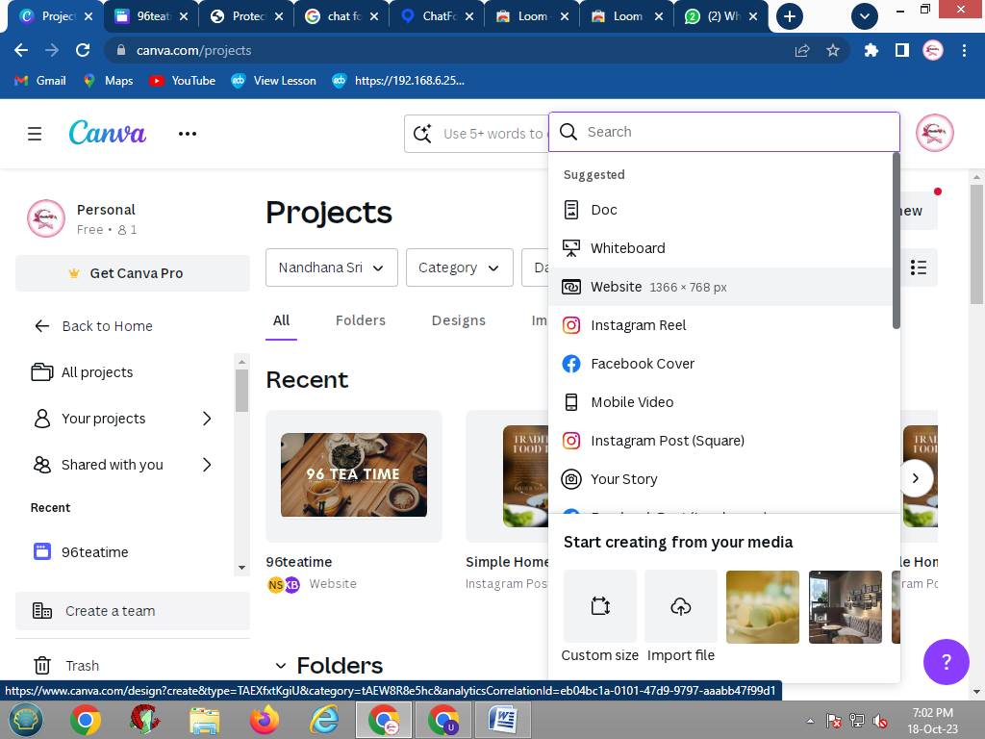 **:**

**CHOOSING THE DESIGN:**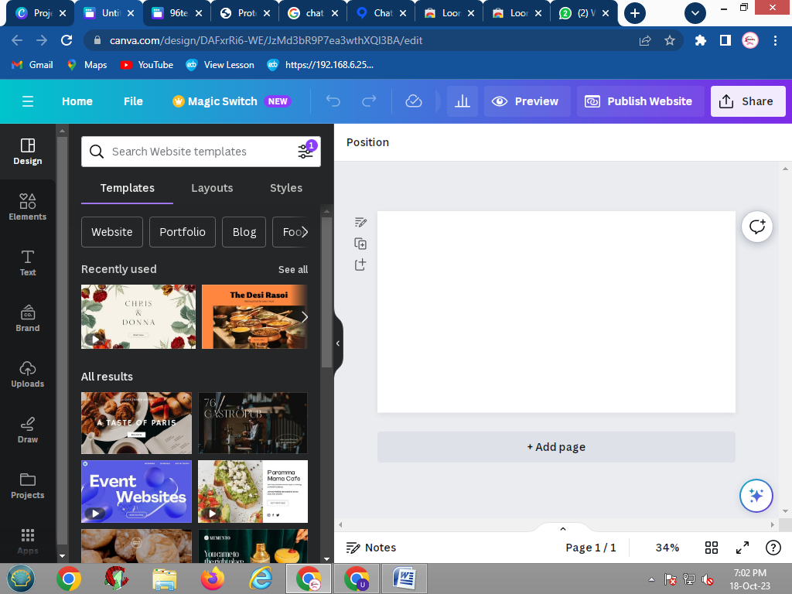

**CHANGE BACKGROUND COLOR:**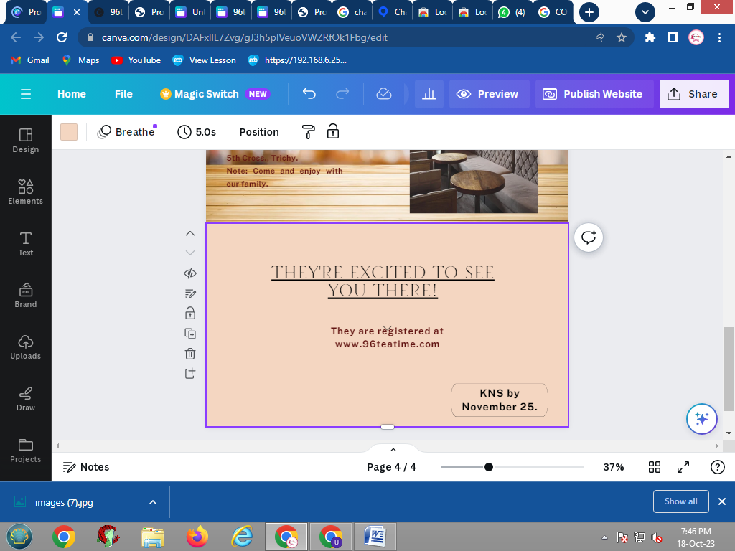

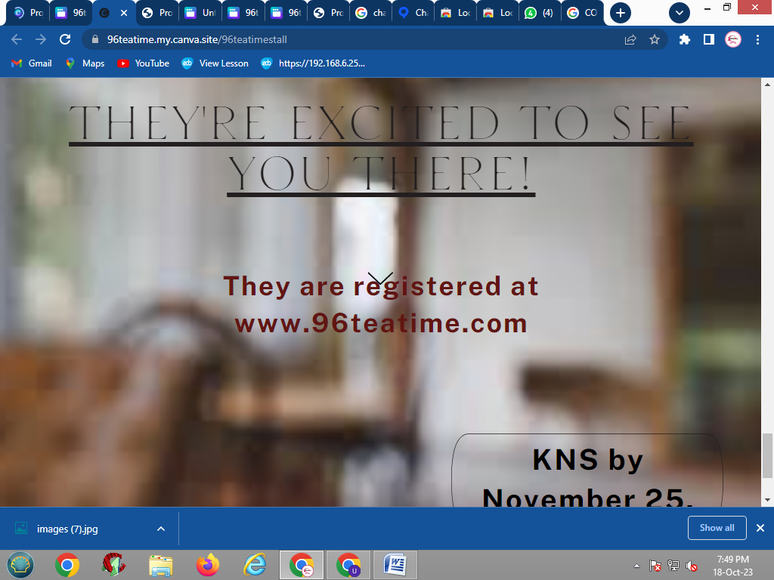**:**

**ADD GRADIENT:**

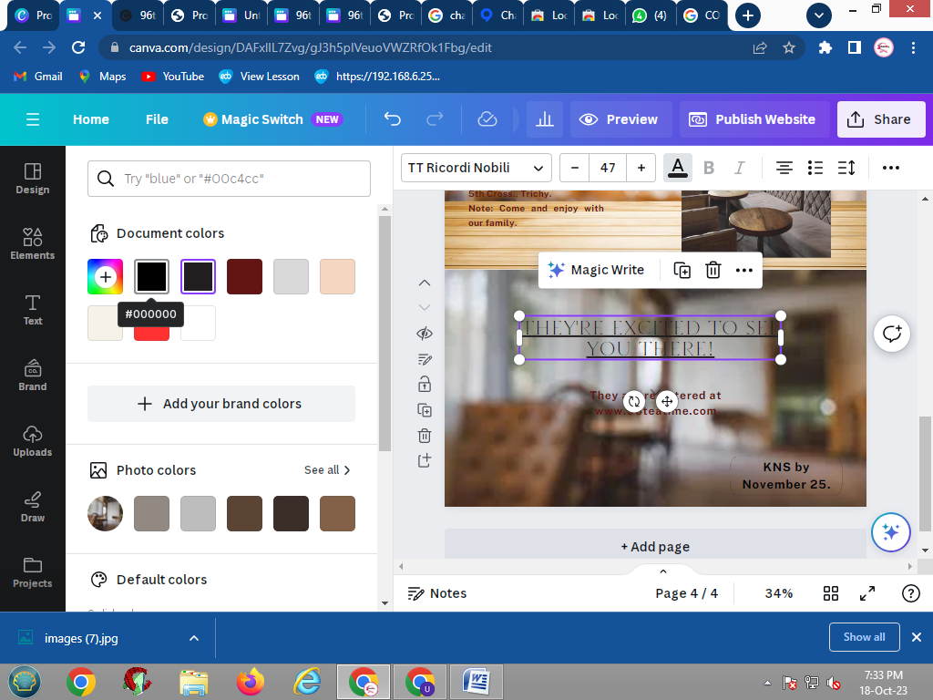

**FINISH EDITING:**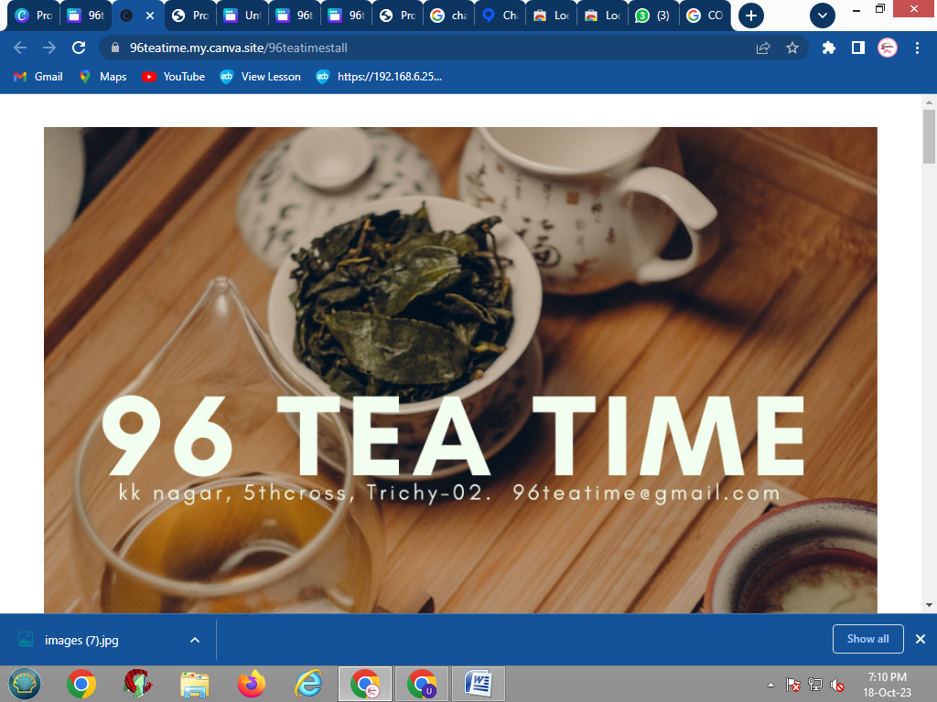

**PUBLISH WEBSITE:**

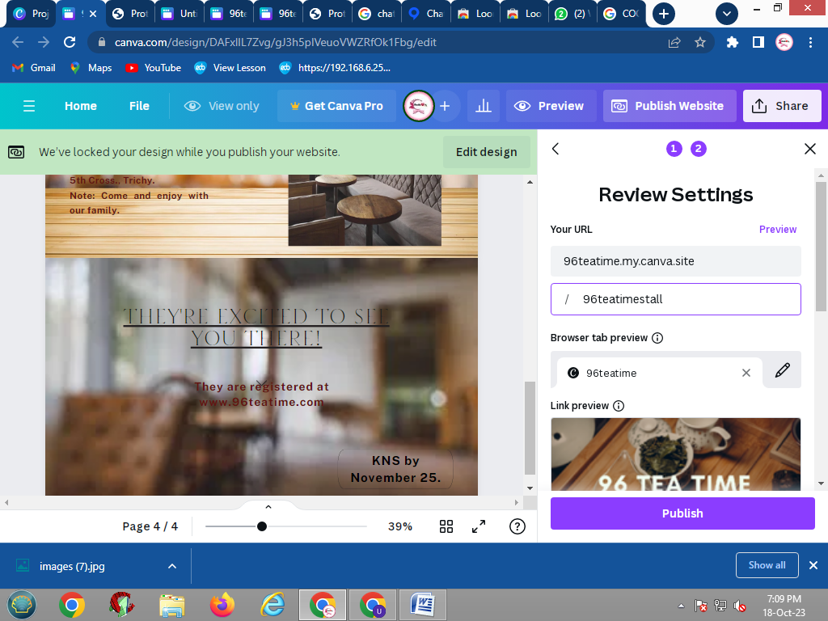

**PUBLISH AND VISIT SITE:**

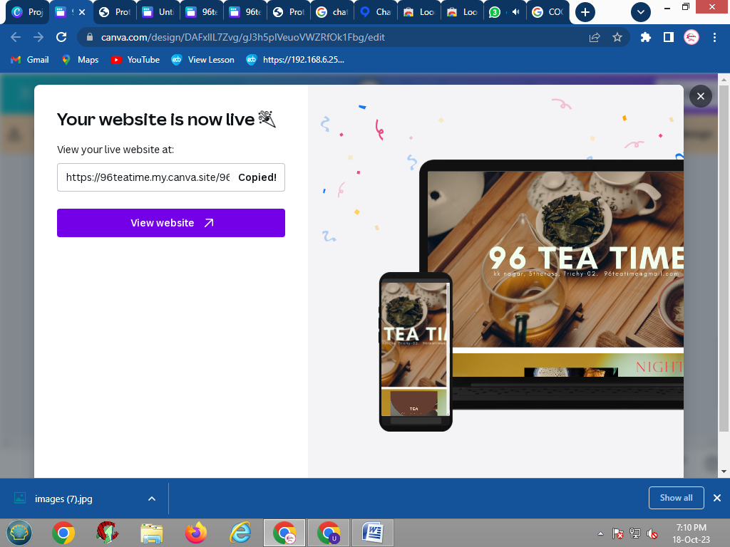

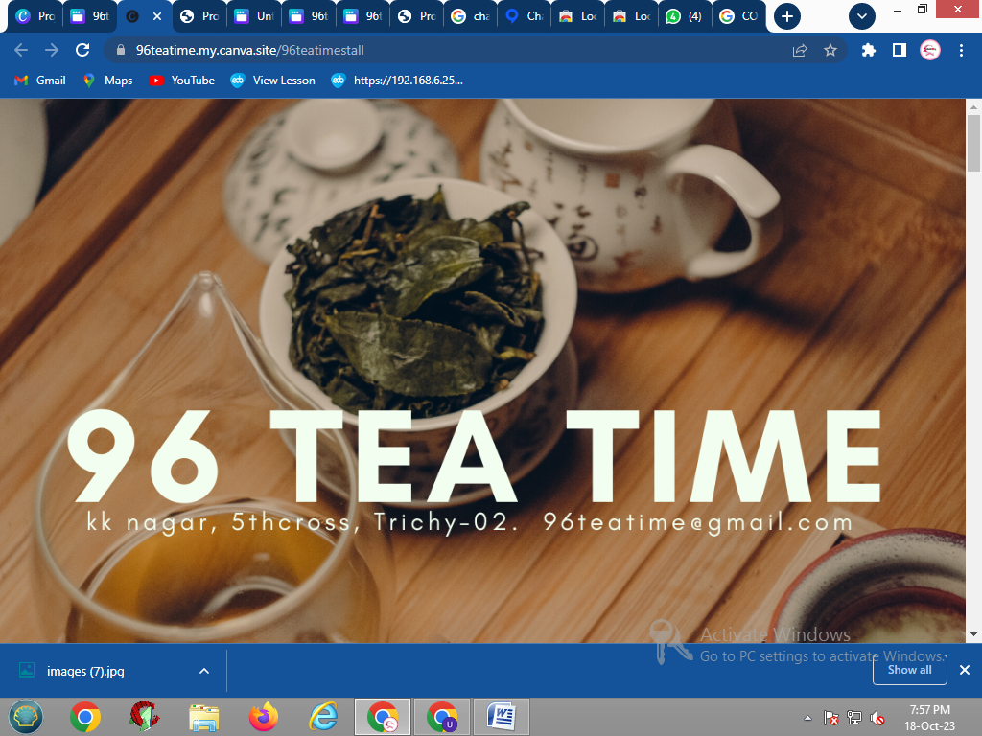

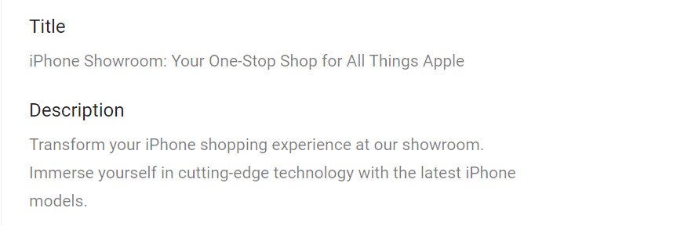

**Page URL:**



**ExternalLinking:**

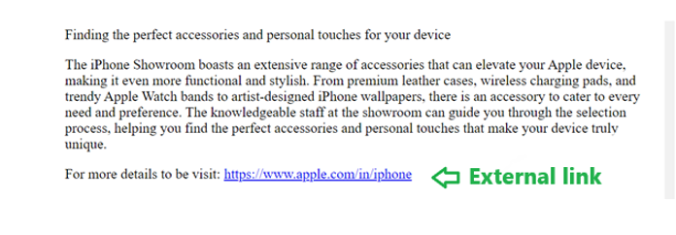



**Mobile Responsiveness:**

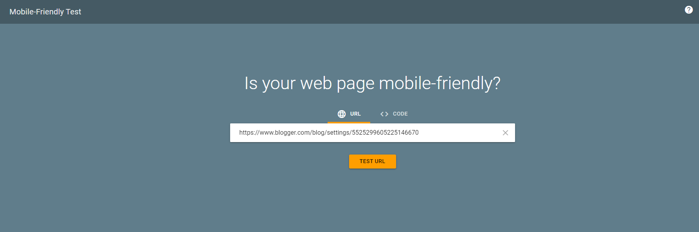



**Site Speed:**



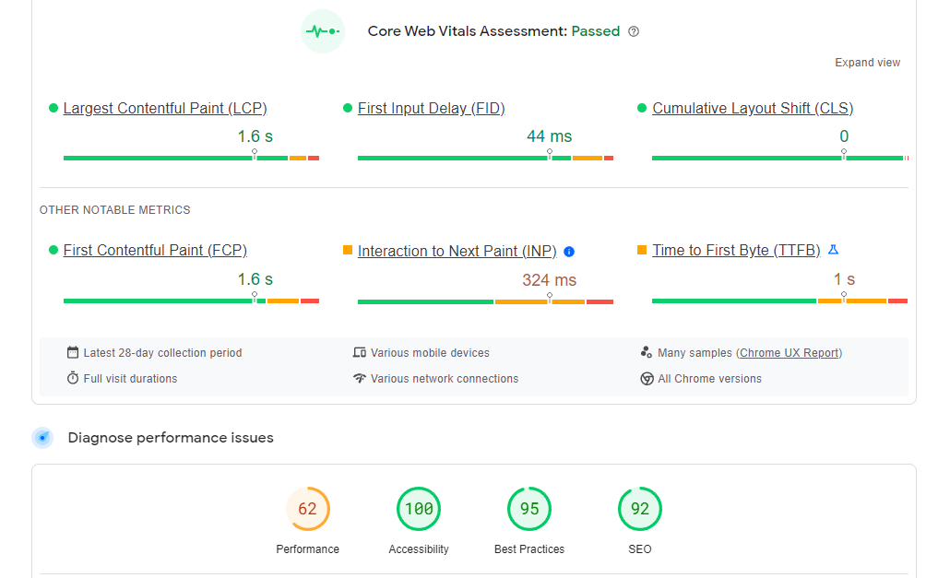

**Structured markup:**

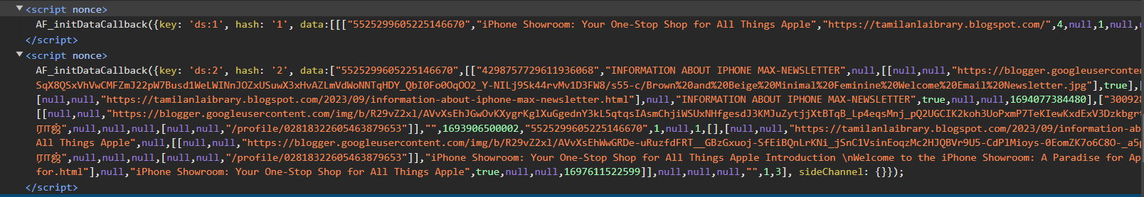

**Internal Linking:**

